Population Classification

Matthew Alter

Christopher Gagen

George Sirbu

Emerging Analytics, VBC – Analytics Center of Excellence



Abstract

The Population Classification model (PopClass) aims to categorize a population into 10 mutually exclusive groups based on care intervention needs. PopClass intention was to go beyond simply identifying patients by high cost or high risk, but instead by similar care needs from a clinical perspective. This would make it easier for care providers to segment their populations for resource allocations and care consideration. Over time a patient could move through multiple buckets depending on how their health changes and that would be reflected in the model.

PopClass was created with a commercial population sample from MarketScan using complete claims data – IP, OP, Rx, and eligibility data. The claims-based model used a supervised decision tree approach for 7 categories and rule-based logic for the more specific 3 remaining categories. The supervised training labels were created with Subject Matter Expert (SME) clinical review of 345 patients. There were 59 variables considered for decision tree modelling, of which 10 variables were ultimately considered significant for the classification of the 7 categories. The claims based model is ready for implementation and use for clients with claims data.

Ultimately ten variables were used to categorize the patients. These variables were calculated from fields that would available in a client’s claims data. The thresholds for the variables were used in various combinations to separate the patient population into their various buckets.

The ten variables are:

1. Number of days since any prior hospital admission
2. Number of admissions in the last 3 months
3. Count of conditions that are both chronic and significant over the last 12 months, utilizes Disease Staging to map ICD-9-CM and ICD-10-CM codes to determine significance
4. Count6mChronicStage3 – Count of Conditions that are both Chronic and severe in the Past 6 months.
5. Count of emergency room visits for chronic conditions in the past 6 months.
6. Days since last major emergency room visit.
7. Count of office visits over the past 12 months.
8. Sum of the days supply of prescription medications over the past 3 months.
9. Sum of the days supply of opiate prescription drugs medications the past 3 months.
10. Count of unique intermediate therapeutic drug classes with at least one chronic drug over the past 6 months as defined in REDBOOK®.

The model applies Truven Health Disease Staging® classification system for various variables. This system helps determine a major event (stage 3 or higher) and if the condition is chronic or acute. Output from the Disease Staging classification is used by eight of the ten buckets in the model.

Model

A Supervised Decision Tree Model was picked for accuracy, interpretability and to allow for expert input. A sample of 345 patient and their medical records over one-year timespan were analyzed by SMEs to develop a training set. The distribution within the training set was more balanced than general population as some buckets with lower prevalence like Crisis Management were very small and needed additional data points for model training. The model considered one year of inpatient, outpatient and drug claims. The Decision Tree Model placed patients in one of seven buckets. Patients are also considered for three different buckets based on a set of rules, as listed in the next paragraph. The patient would ultimately end up in the more severe category if they qualified for more than one. This resulted in ten total buckets which patients could end up in. The ranking of the 10 categories is in the list below, ranging from low to high.

Engagement – Patients with little medical history and often do not have an established relationship with a care provider.

Prevention – Generally healthy individuals with the possibility for a minor but controlled condition such as hypertension or gastric reflux. Interventions are likely to be along the lines of wellness care tips.

Support – This bucket mostly comprises patients with chronic conditions like diabetes but seem to be well managed. Care management with these people will involve tips and information to continue to live with and manage their condition successfully.

Treatment Navigation (rule)– These individuals have been recently diagnosed with a new condition which has multiple potential treatment paths. The goal is to help patients understand their options and select the most appropriate approach for them.

Coordination – Patients with multiple chronic conditions who may see multiple providers for care. Needs help managing medications and coordinating a consistent and cohesive treatment plan.

Monitoring – Utilization of medical services suggests a need for guidance and education of better approaches.

Rebalancing (rule) – Recently experienced a major event, surgery or diagnosis where a new normal need to be established. Help is needed in finding that new normal in the form of intensive care or coping mechanisms.

Recovery Guidance – Recently experienced a major event or surgery but full recovery is expected. Needs temporary assistance returning to baseline.

Surveillance (rule) – These patients already have an established relationship with a healthcare system due to treatment for a serious condition (chemotherapy, dialysis, organ transplant). Patients may only need some support and observation along their care path.

Crisis Management – Most severe group where patients have extremely serious conditions that are not well controlled. Interventions may focus on preventing catastrophic events or assisting with end of life arrangements.

In addition to bucketing patients, the model provides which node ultimately categorized the patient. This information allows for understanding of what combination of factors went into the patient’s placement. For example, a patient must have had all the conditions below to be categorized in Coordination:

* Day’s supply of opiates = 30
* Significant chronic conditions in the past year = 5
* Days since their last inpatient admittance = 45

Model Validation

To validate the model 345 patients that were evaluated by a SME were run through the model and the results were compared. This group included 305 patients that were used to train the model’s 7 buckets for placement plus 40 more patients for the rules based buckets. Those 40 patients were kept out of the training set to reduce noise that would result from the model trying to fit data that would never be correct.

The results are below with an overall accuracy of 83%. The diagonal down the center of the table represents accurate predictions. Predictions that landed to the right of the diagonal are misses in a less critical bucket. These are of concern because they represent patients that may need a higher level of intervention. There we few critical misses – ones where a patient would receive little to no intervention – but some did happen in Monitoring and Coordination.

|  |  |  |  |  |  |  |  |  |  |  |  |
| --- | --- | --- | --- | --- | --- | --- | --- | --- | --- | --- | --- |
|  |  | **Prediction** | | | | | | | |  | |
|  |  | Crisis Management | Recovery guidance | Monitoring | Coordination | Support | Prevention | Engagement | Total | |
| **Actual** | Crisis Management | 10 | 0 | 1 | 1 | 0 | 0 | 0 | 12 | |  | |
| Recovery guidance | 1 | 6 | 1 | 0 | 0 | 0 | 0 | 8 | |  | |
| Monitoring | 0 | 3 | 17 | 1 | 1 | 3 | 0 | 25 | |  | |
| Coordination | 0 | 0 | 4 | 11 | 4 | 4 | 0 | 23 | |  | |
| Support | 0 | 0 | 0 | 1 | 57 | 14 | 0 | 72 | |  | |
| Prevention | 0 | 0 | 0 | 1 | 5 | 140 | 1 | 147 | |  | |
| Engagement | 0 | 0 | 0 | 0 | 0 | 4 | 14 | 18 | |  | |
|  | Total | 11 | 9 | 23 | 15 | 67 | 165 | 15 | 305 | |

Market Scan Analysis

After training the model was run on two populations. Five consecutive quarters were modeled form Dec 2013 to Dec 2014 of one specific client’s (CLIENT) patient population and two quarters of a 10% random sample of MarketScan (MS) was run on Dec 2013 and Dec 2014. This data was used to evaluate and validate the model.

With a reasonably accurate model, the next step was to see how stable CLIENT’s population was across multiple years and compared to a much larger MS sample. While any individual patient may move from one bucket to the next as their health status changes, an entire population is likely to remain rather stable over time. As a result, CLIENT’s 2013 and 2014 enrollment was compared to the 10% MS sample to see how they compare.

As the figure above shows, there is reasonable agreement in the bucket distribution between all the samples with a couple notable exceptions (Treatment Navigation and Rebalancing). Differences between the populations can be expected for multiple reasons (i.e. presence of an engagement program, make up of workforce, nature of work, other employee health programs) and explain why CLIENT’s distribution doesn’t match up directly with the MS sample. However, it is more difficult to explain the nearly doubling of patients in Treatment Navigation and almost 50% increase in Rebalancing within CLIENT’s patient population.

Per member per month (PMPM) is a broad way to look at resource consumption within each bucket. The figure below shows PMPM for each bucket for years 2013 and 2014. Three main buckets stand out from the rest when it comes to cost: Crisis Management, Recovery Guidance and Surveillance. The spikes in PMPM for Crisis Management and Recovery Guidance is not surprising given that many of these patients have experienced an acute event such as a surgery or something catastrophic resulting in expensive care. Surveillance patients have multiple expensive conditions that they are trying to balance and manage.

Below is another look at the PMPM figure above without the three most expensive buckets dwarfing the rest. Three of the four buckets here show a similar pattern and scale – Engagement, Prevention and Support. For the most part these are relatively low touch populations that need gentle nudges to keep them on track, provide a little information or get them moving in the right direction.

Rebalancing and Treatment Navigation both show a somewhat similar pattern of a spike followed by costs settling at an elevated rate. Both these buckets focus on patients that have experienced some event (spike) and need to find a “new normal” and must negotiate several options for treatment (elevated rate).

The last two buckets are Coordination and Monitoring. Monitoring patients show a pattern of inappropriately utilizing services and show need for some guidance. Some potential misuses may be relying too heavily on the ER for care and not seeing a care provider with chronic conditions. Like Monitoring, Coordination patients need help navigating the web or patient care and utilizing services in an efficient and productive manner. except that the patients have multiple chronic conditions and are seeing care providers for them. However, unlike Monitoring, these patients have multiple chronic conditions and may already be seeing providers for care.

Model Consistency

To better understand how patients flowed through buckets the PopClass model was run on 5 quarters worth of CLIENT data (2013Q4-2014Q4). It is important to see and understand the pathways which patients took as they progressed from more serious to less serious buckets and vice versa. One nice tool for this are Sankey diagrams which visually depict the flow from one state (node) to the next. This diagram shows how entire groups move, but does not lend insight to the activities of any individual.

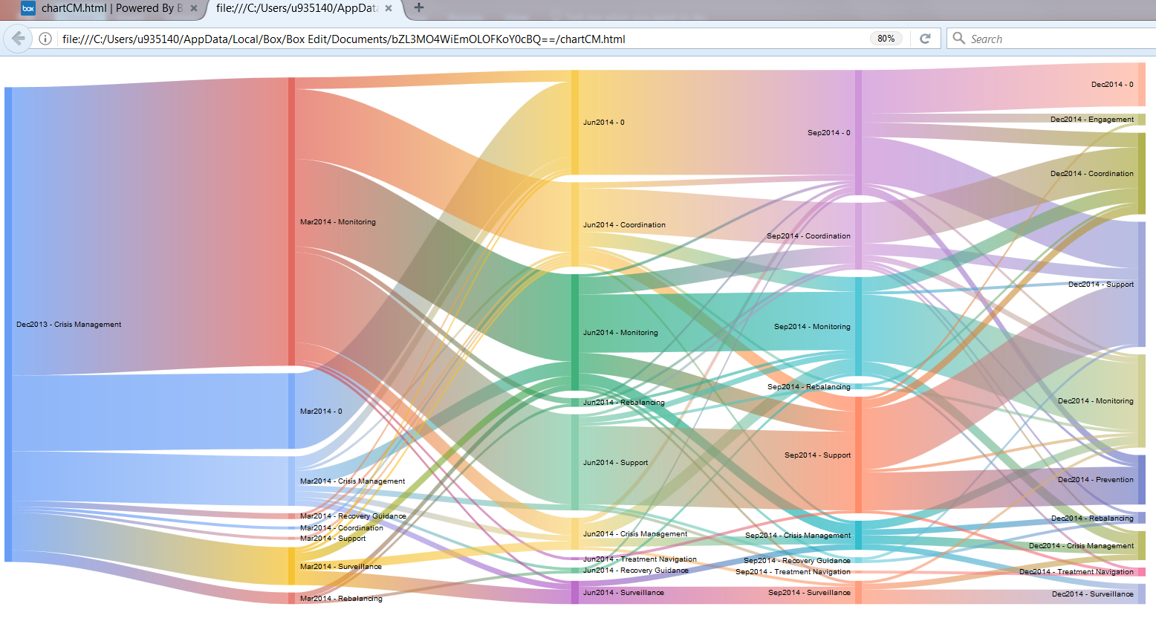

The diagram above shows all the patients that started in Crisis Management (the highest bucket) in 2013Q4 (far left) and how they moved through the buckets over time. Every patient represented in the diagram started in Crisis Management and no new patients enter the system at any time. Very few patients remained in Crisis Management after the 2013Q4 (as expected) with most moving to Monitoring. After that the buckets began to level off in size and their distribution become more stable. Some patients do move back into Crisis Management (some from Rebalancing, some from Monitoring, etc.), so these might be of extra interest as they have suffered multiple major problems in the same year. This sample was relatively small with about 150 patients total. Larger patient populations show greater stability right from the beginning.

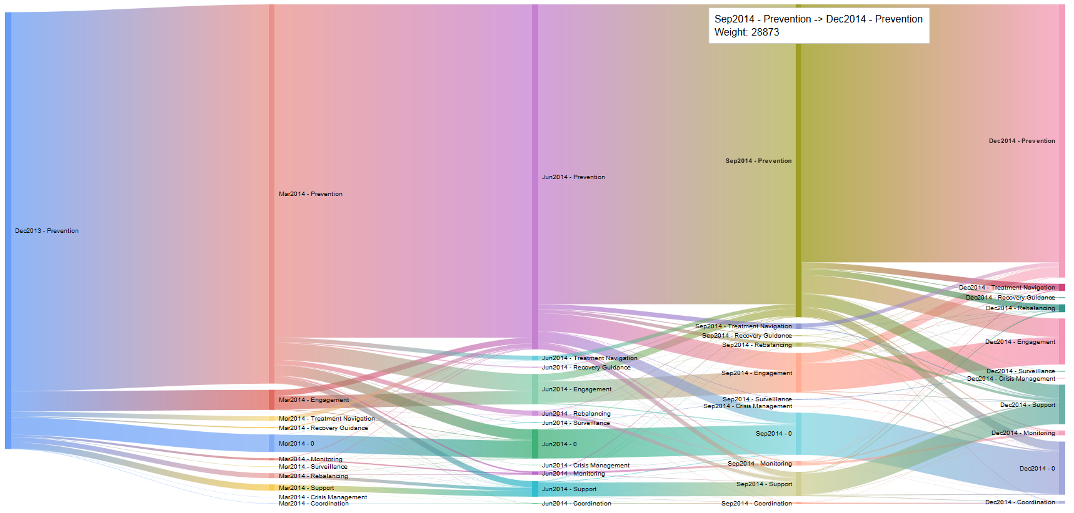

Consider the Sankey diagram Above. All patients (42k) began in the Prevention category. Each quarter some moved to other buckets but many stayed within Prevention. The two largest recipients of patients were the null bucket (patients who left the system) and the Engagement bucket (patients with little to no activity). The movement from Prevention to any one specific bucket is relatively stable throughout the year. For example, movement from Prevention to Support totaled 700, 669, 603, and the outlier of 1455. It could be hypothesized that the outlier occurs because patients look to maximize their deductibles at the end of the year and thus more falling under support. Movement from Prevention to Null was 1957, 1192, 1221, and 965. It could be hypothesized that the first quarter’s movement is the largest because patients have chosen different coverage for the new year.

More examples of these Sankey diagrams are available on request. These diagrams are rendered in a browser and allow the user to interact with them and see the number of patients that pass between each node.

Cost (PMPM) Trends

In the Appendix there are multiple graphs comparing the mean PMPM cost of each bucket across three populations: CLIENT 2013, CLIENT 2014, and MS with MS median value in for comparison. For the most part the PMPM average is significantly higher than the median value. This means that relatively few very high cost patients are pushing the overall average much higher than the median. The only places that this doesn’t happen is with Recovery Guidance, and like Prevention and Engagement (need to get median values). In most cases the median PMPM has a similar curve to that of the means. Future work may consider looking at the behavior of the most expensive actors and see if they vary from the rest.

Another interesting characteristic is that some buckets return to roughly the same PMPM level while other buckets settle at a significantly higher value. Many of the patients settling at a higher level are finding that “new normal” and level of care to manage their conditions.

Conclusions and Future Considerations

The Population Classification addresses the market needs of having a model for stratifying a cohort based on care management’s needs. While the evaluation at the individual level it is hard to assess given the subjectivity in such endeavor, the analysis in larger population are more significant and interesting to address.

Two large samples from MarketScan was used to investigate the PopClass and the general trends and population distributions show results that are consistent with our expectations for the model behavior. Given the large sample that was used for the analysis, we can also recommend that the results can be used as benchmarks for further studies.

For future work, it will be interesting to study the PopClass model results as applied to specific diagnosis cohorts or how it correlates with other models based on cost or resource’s utilizations.

# Appendix